Good Information Sources for topic “Intensive vs. organic farming” – year 7
Use different search words eg “farming”, “organic farming”, “intensive farming” etc
- Eclipse
  - Searches 9,000 educationally approved websites
  - Find websites through searching “farming” on Eclipse eg
    - Insights – magazine of the international food policy research institute
    - Farming & Countryside Education – search organic farming to find a fact sheet
    - Compassion in world farming
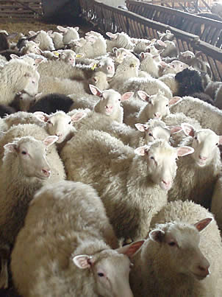
  - Use the other search words as well
  - Look for links to other good websites
- Use BBC Bitesize:
  - www.bbc.co.uk/schools/gcsebitesize
    - Search “organic farming” and “Intensive farming”
- Complete Issues another good source of current information
  - www.completeissues.co.uk
    - Username –Sibford
    - Password – Sibford
- Good websites
  - Follow links from good sources to find other good websites eg:
    - www.organicresearchcentre.com
    - www.face-online.org.uk/discovering/fact-sheets-discovering
    - www.gardenorganic.org.uk
    - www.soilassociation.org/whatisorganic/organicfarming
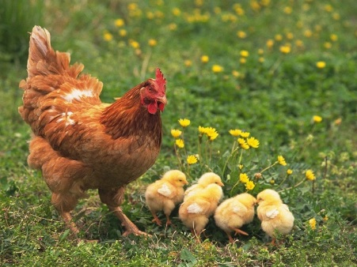
- Reference Online
  - Google Oxfordshire reference online”
  - Click on “At home”
  - Choose relevant information sources,
    - Encyclopaedia Britannica has some good articles!
  - Use UK Newsstand to find recent newspaper articles
  - Scroll down and click on UK Newsstand
  - Enter your library membership or borrow Frances King’s for this session – 800068362
  - Search eg “farming”, “intensive farming”, “organic farming”
  - Refine
    - Go to “Relevance” on right hand side
    - Click on drop down bar and choose most recent first
    - Go to Publication title drop down bar
    - Choose a title eg “Daily Mirror”
    - Adapt search by choosing different search terms and newspapers
    - Use articles to find other sources of information
- Books
  - Books may include a vital snippet of information the you would not find elsewhere
  - Use the index of the books to find these vital snippets! -use the same keywords that you would use in internet searches

