Foundation paper B4 C4 P4 Jan 2012 (amended for new spec)
Markscheme
1
[Total: 7]
2
3
[Total: 3]
4
(a)
(b) (6 mark question)
Relevant Points
- Anaerobic respiration occurs without oxygen
- Word equation for anaerobic respiration in humans given
- Word equation for anaerobic respiration in microorganisms given
- Energy is produced from anaerobic respiration in both humans and microorganisms
- Lactic acid produced in humans is a waste product, and is toxic in large amounts
- Ethanol produced by microorganisms can be used for things such as alcoholic drinks
- Anaerobic respiration in yeast can produce bioethanol that can be used to fuel car engines
- Anaerobic respiration in bacteria produces biogas that can be used as a fuel
Level 3 (5-6 marks)
Answer correctly and clearly identifies the difference between anaerobic respiration in humans and microorganisms. Candidate shows lactic acid is produced by humans, and ethanol and carbon dioxide is produced by microorganisms. At least two uses of the products of anaerobic respiration are described, and lactic acid is identified as a waste product. Points are presented in a clear, coherent and organised format. Few, if any, errors in grammar, punctuation and spelling.
Level 2 (3-4 marks)
Answer correctly outlines the difference between the products of anaerobic respiration between microorganisms and humans. At least one use of the products of anaerobic respiration in microorganisms is described. Technical terms are used for the most part appropriately. There are occasionally errors in grammar, punctuation and spelling.
Level 1 (1-2 marks)
Answer describes what anaerobic respiration is, but does not fully identify what the products of anaerobic respiration in microorganisms and humans are. Candidate may identify one use of the products of anaerobic respiration. Answer may be simplistic with limited use of technical terms. Communication is hampered by errors of grammar, punctuation and spelling
Level 0
Insufficient or irreverent science. Answer not worthy of credit
[Total: 8]

5
6
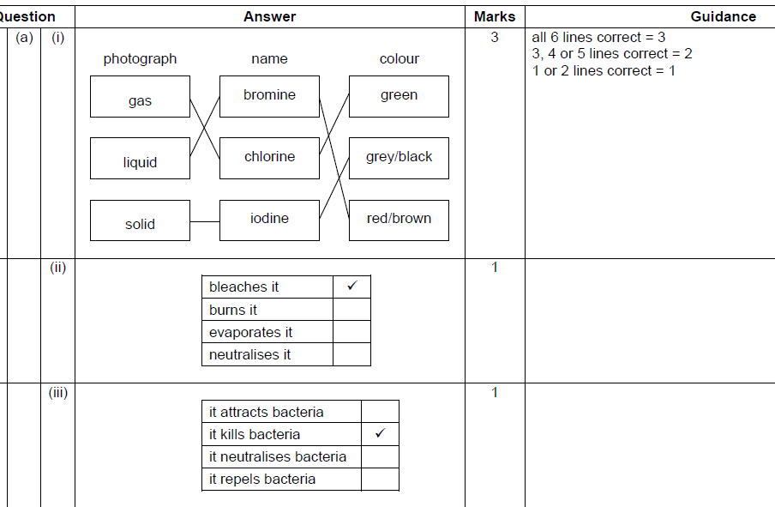

7
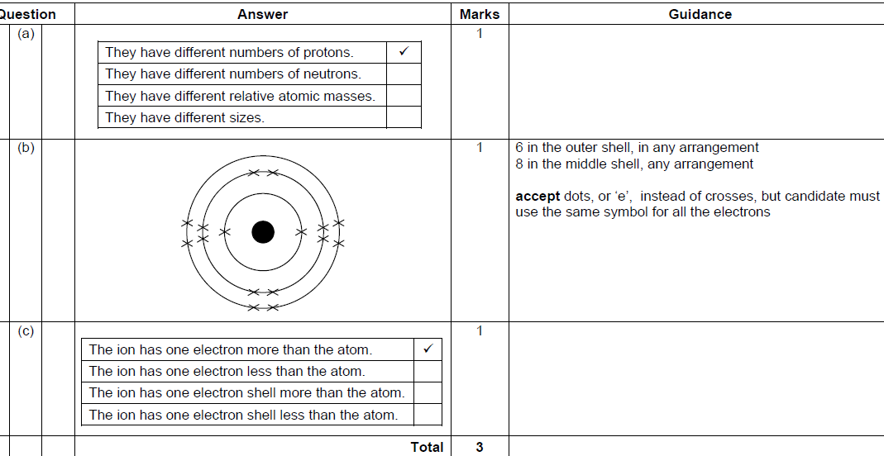

8 (6 mark question)
Any mention of 6 of the following:
Caesium and Rubidium are group 1 metals / alkali metals.
Group 1 metals are highly reactive.
Highly reactive elements are not found in their elemental form in nature.
Spectroscopy gives line spectra
Line spectra are different for each element
The position or colour of the line depends on the energy level of the electrons in the element.
Bohr explained the line spectra from atoms.
Mention of electron shells or energy levels
Drawing of an atom, illustrating electron arrangement.
Drawing of an emission spectra.
-Or any 5 of the above and well written gains 6 marks with 1 mark awarded for spg.
9
10
11

Q | Expected answers | Marks | Additional guidance
12 | [Level 3]  Includes most relevant points in each category in the answer. Describes the energy transfer accurately including dissipated energy and possibly calculates final velocity. Explains the link between force, change in momentum and impact time. All information in answer is relevant, clear, organised and presented in a structured and coherent format. Specialist terms are used appropriately. Few, if any, errors in grammar, punctuation and spelling.  (5 – 6 marks)  [Level 2]  Outlines the energy transfer but leaves out some details like friction or sound energy. Is able to link the ideas of impact time with force but may not discuss change in momentum. For the most part the information is relevant and presented in a structured and coherent format. Specialist terms are used for the most part appropriately. There are occasional errors in grammar, punctuation and spelling.  (3 – 4 marks)  [Level 1]  Outlines the basic energy transfer with no reference to frictional forces or dissipated energy. May be able to link danger to force and either impact time or momentum. There may be limited use of specialist terms. Errors of grammar, punctuation and spelling prevent communication of the science.  (1 – 2 marks)  [Level 0]  Insufficient or irrelevant science. Answer not worthy of  credit.  (0 marks) | [6] | relevant points include;  Describing the energy transfer;  - Portia’s gravitational potential energy is transferred in to kinetic energy during the fall  - Some energy is transferred to heat and sound due to friction and air resistance  - Travelling approximately 40 m/s when she hits the mat.  Explaining how it was safe to make the jump;  - The force needed to stop an object depends on the change in momentum and impact time  - If the impact time is small the force needed to stop the object is large  - Hitting a hard surface (like the ground) the impact time is very small so the force is large  - Hitting a soft object (like a mat) the impact time is much longer so the force is smaller  - If the force is smaller then she will be safe jumping off the building.  accept use of formula F = change in momentum/time  reject ideas that the mat is ‘soft’ so it is safe
 | Total | 6

