B5 Revision questions
DNA and cells

Explain the function of each of these cell parts:
Ribosome
Nucleus
Mitochondrion
Cell membrane
cytoplasm

Name the 4 bases that make up DNA

Which bases pair with which?

Here is a strand of DNA. Draw in the other half of the DNA strand.

A C C G T A T A G G C G A C T T

What is the double helix?

Who came up with the idea of the double helix?

Is the double helix a theory or a fact? Explain.

Explain the structure of DNA.

What’s another word for ‘replication’?

Fertilization and early development

Label the parts of the reproductive system. What is the role of each part?
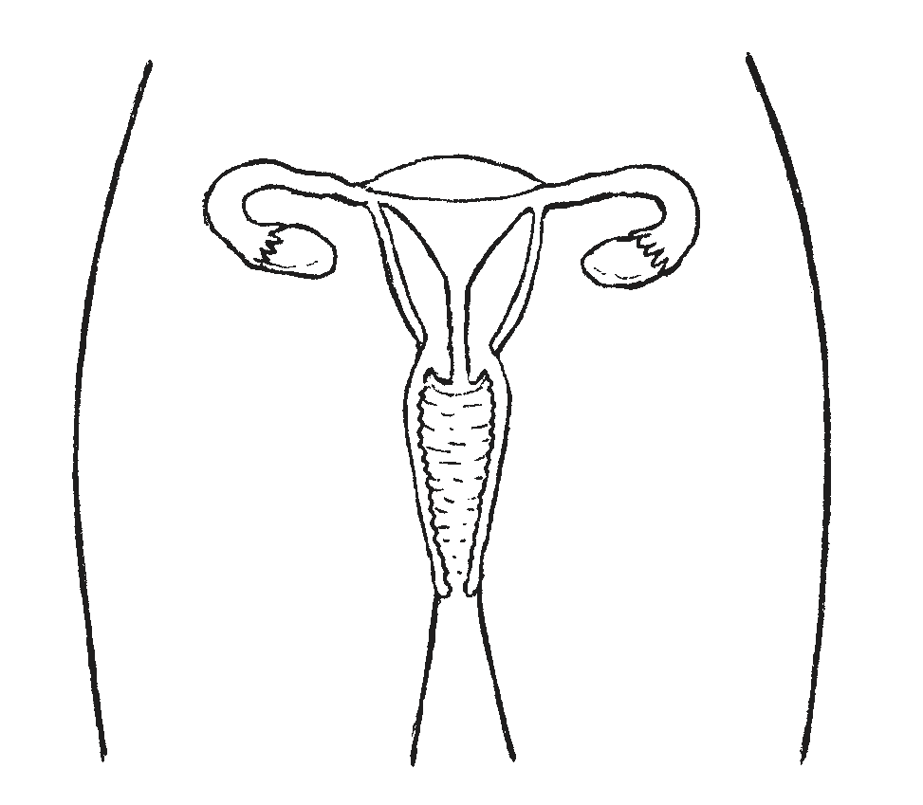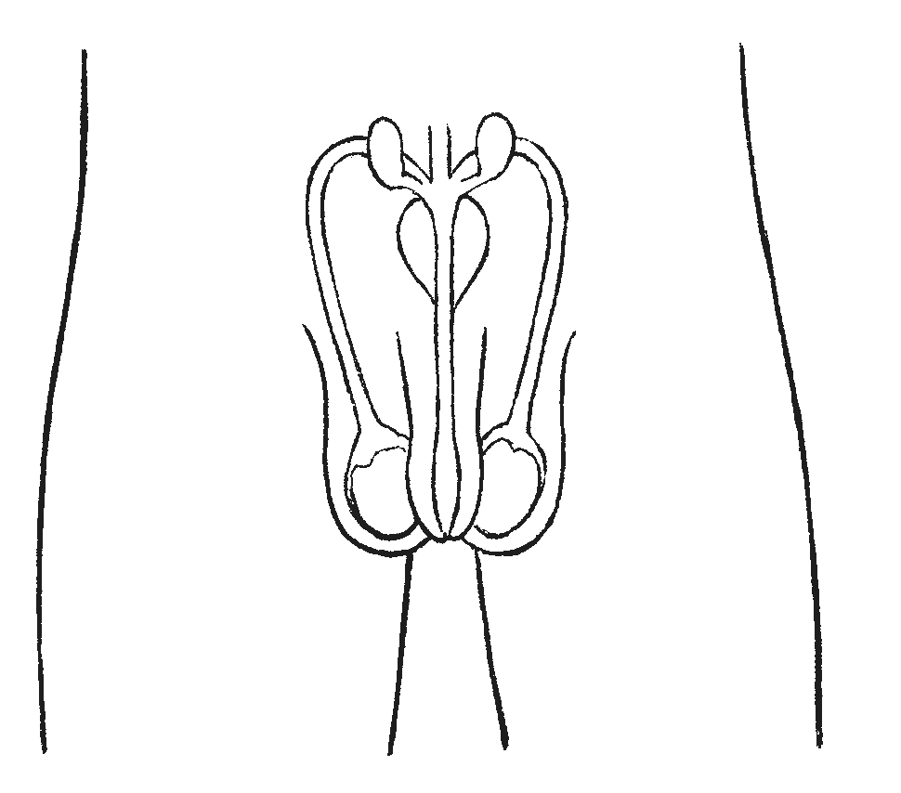

What happens during fertilization?

Where does fertilization happen naturally?

What is IVF?

Why do some couples use IVF to get pregnant? Give at least 3 reasons.

Define the following terms
gamete
zygote
blastocyst
embryo
foetus

What is ‘implantation’ and when does it happen?

What does it mean if a cell is haploid?
What does it mean if a cell is diploid?

How many chromosomes does a diploid human cell have?

When are the chromosomes x-shaped?

What is a parent cell?

What is a daughter cell?

Complete this table about mitosis and meiosis:
 | Mitosis | Meiosis
How many daughter cells produced?
Daughter cells identical? Y/N
Daughter cells haploid or diploid?
Example of cells produced

What is one way that mitosis and meiosis are similar?

List 2 differences between mitosis and meiosis.

What does it mean if someone has trisomy (as in, trisomy-21, or trisomy-13)?

How does trisomy happen?

What usually happens to embryos with trisomy?

Proteins

What is a gene?

How many bases code for a single amino acid?

Explain the relationship between DNA, genes and chromosomes.

Name at least 3 different proteins.

Give at least 3 different functions of proteins.

How are proteins made in the cell?

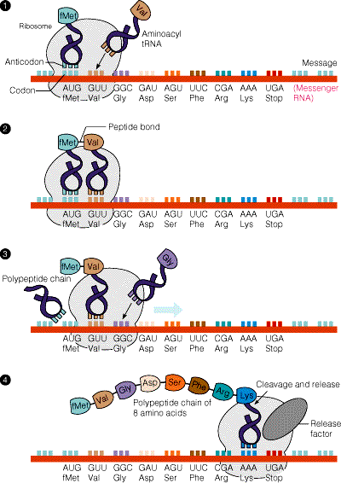

All of these steps occur during protein synthesis. Put them in order.

A) mRNA strand leaves the nucleus through the nuclear pore
B) mRNA makes a copy of the gene for the desired protein
C) mRNA strand goes into the cytoplasm
D) amino acids bind to make a protein
E) ribosome attaches itself to the mRNA strand
F) DNA unzips
G) anti-codon on tRNA (which has an amino acid attached) binds with codon on mRNA strand

The first one has been done for you.
F

What is the job of the ribosome in protein synthesis?

Give at least 2 differences between DNA and mRNA.

Here is a strand of DNA. Draw in the mRNA strand that would be made during transcription.

A C C G T A T A G G C G A C T T

Ethical considerations

What is ‘genetic screening’? When can a cell be taken for screening?

Why are some people against genetic screening of embryos?

What is embryo splitting? When can you split an embryo? Why can’t you split it after that point?

Why would someone want to split an embryo? What are the benefits? (think animal embryos as well as human)

Animals produced by embryo splitting are clones. Clones of what?

What does it mean when we say stem cells are ‘unspecialised’?

What happens when cells start to specialise?

What does it mean if a gene is ‘being expressed’?

Why do cells only produce the proteins they need?

Where do you find adult stem cells? What kind of cells do they become?

What is a clone?

Does cloning happen in nature? Explain.

What is ‘nuclear transfer’ and what does it have to do with cloning?

Why should it be possible to use any body cell with a nucleus to create a clone?

What’s the difference between reproductive cloning and therapeutic cloning?

Which type of cloning is less controversial? Why?

Stem cell research:
What are at least 2 reasons why some people support it? | What are at least 2 reasons why some people are against it?

Cloning (of animals and humans)
What are at least 2 reasons why some people support it? | What are at least 2 reasons why some people are against it?

Plants

What is the meristem?

How does the meristem affect plant growth and development?

What is a similarity between meristem tissue and embryonic stem cells?

What is the biggest difference between meristem tissue and embryonic stem cells?

What is the role of auxin in plant development?

Name and briefly describe 2 ways that you can clone plants.

Why might farmers/gardeners want to clone plants?

What is a tropism?

What is phototropism? How does it help plants survive? (hint: you need to explain the role of auxin).

Explain the growth of the plant shoots in the diagram. What does it tell us about phototropism?

4 days

Name at least 2 other types of tropism.

